Boeing Employees Golf Association
Brassie Lassie Ladies Golf League
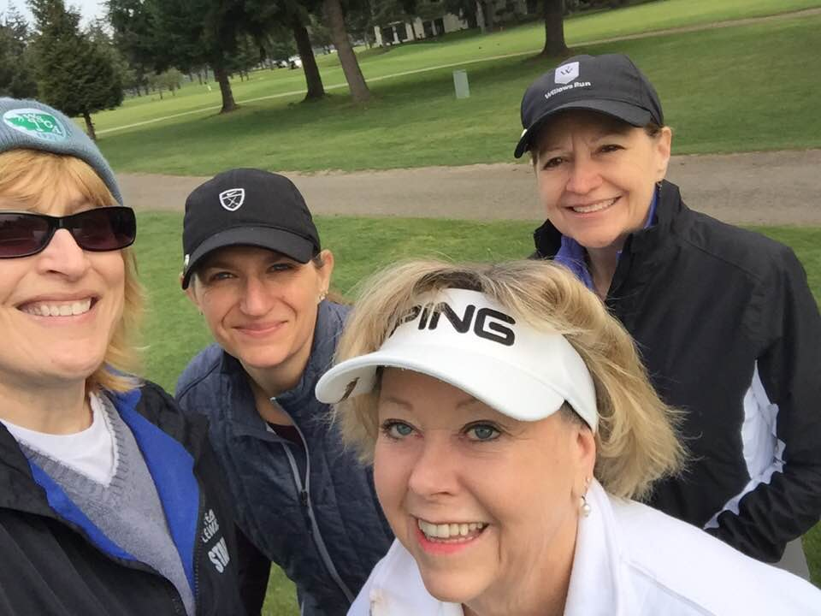
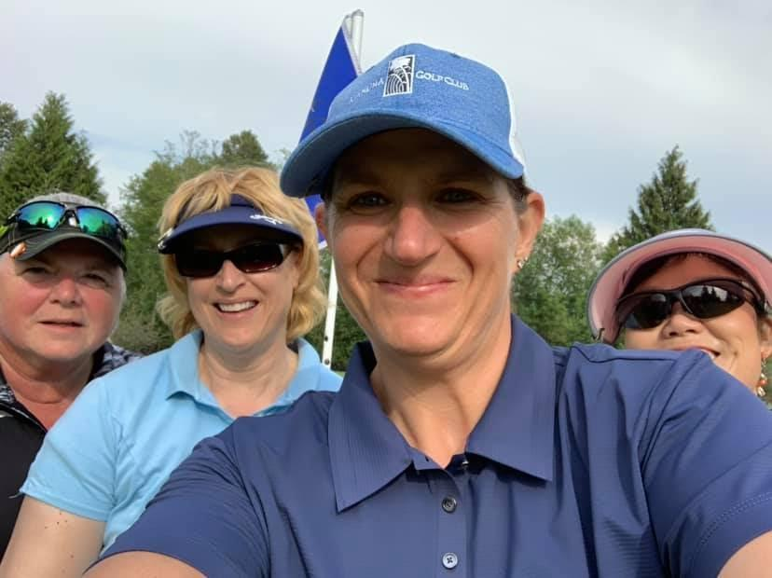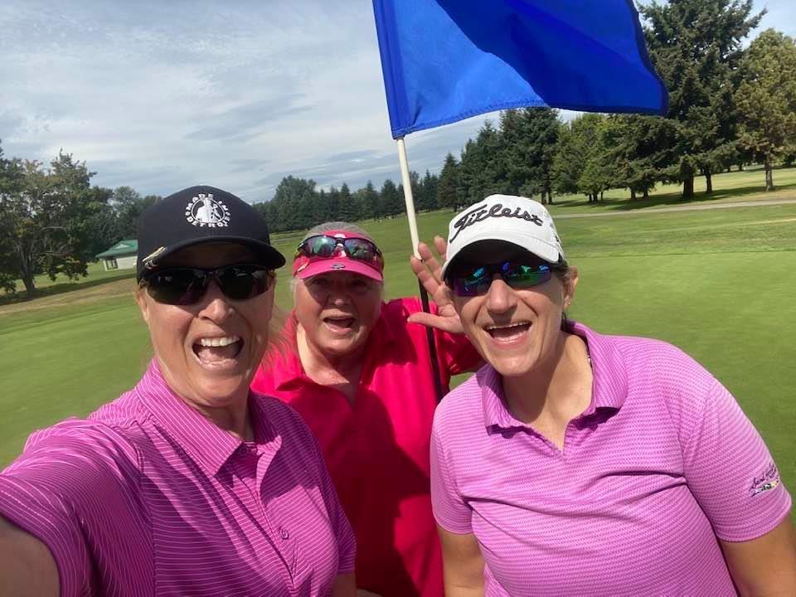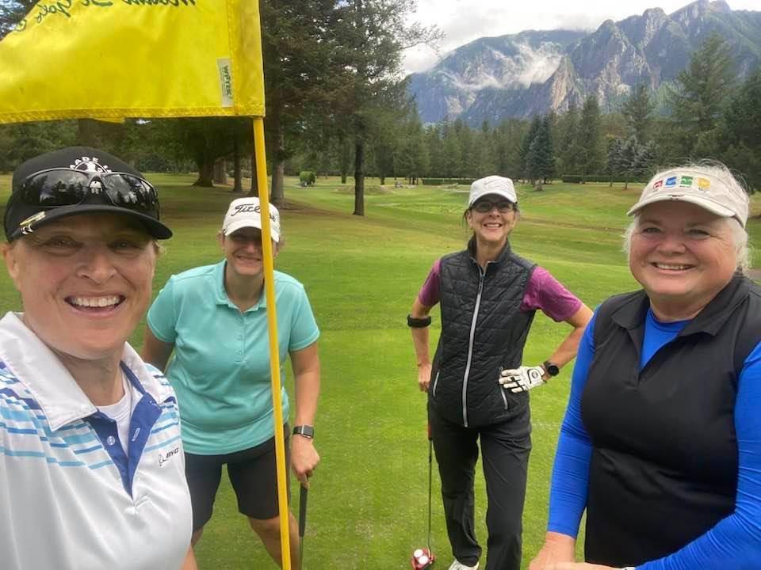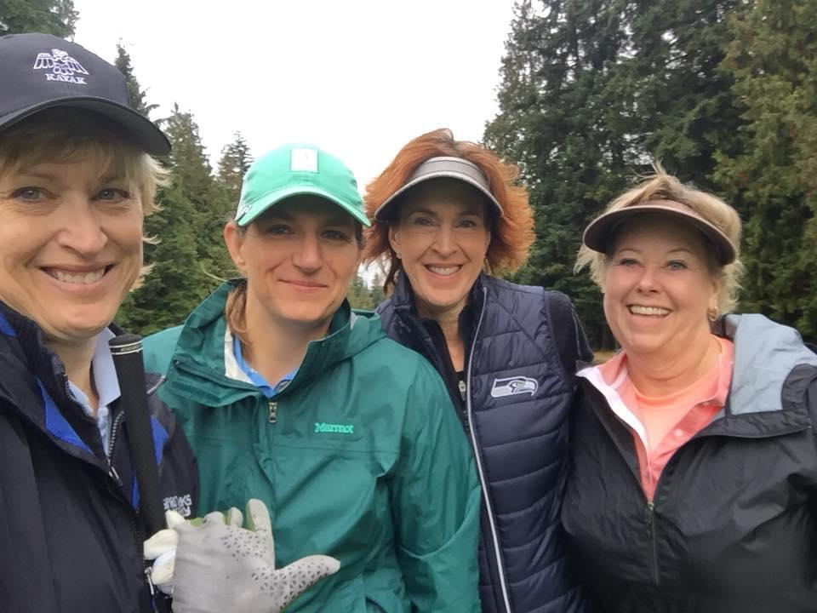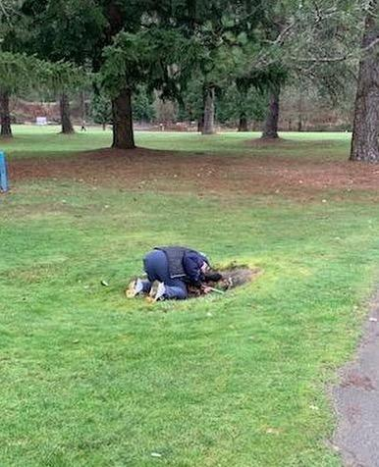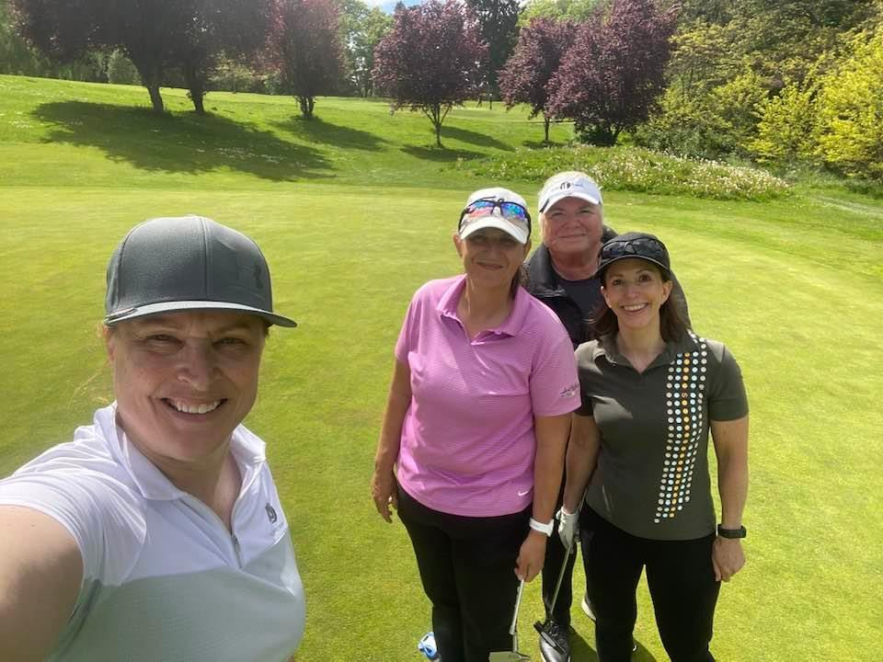

Maplewood (Renton) – Wednesday 4:12pm
League Play Begins Wednesday, April 10, 2024
****Accepting Members All Season Long – Join Today****
The 2024 Schedule
First half league plays April 10 – June 19 Second half league plays July 17 – September 11
Note: No league play on May 8, May 15

Brassie Lassie Officers:
President: Carrie Tiersma 206-940-5111 ctiersma@gmail.com
Vice President: Clare Seibel 425-681-7487 csrn24@yahoo.com
Secretary: Liz Willetts 425-761-9790 shadylake@hotmail.com
Treasurer: Sarah Lestock 425-306-9778 Sarah@TheLestocks.com

We look forward to seeing everyone this season. If you know ladies who would like to play, let them know that we are accepting new members. If you have any questions, feel free to contact any of the officers.

Thanks,
Carrie and Clare

Brassie Lassie Golf League
Membership Application
Name______________________________________ GHIN ____________ (Apply via WWW.BEGAGOLF.ORG )
Home Address__________________________________________________________________
City, State, Zip__________________________________________________________________
Phone_______________________ Email Address____________________________________________
Since there are some blocking issues when sending to Boeing email from a home email, please provide a personal e-mail address when possible. Use email/text for weekly distribution? Yes: ◻ No: ◻
Boeing Employee: ◻ Retiree: ◻ Contract/Supplier: ◻ Former Employee: ◻ *Associate/Family: ◻
*If you are an ASSOCIATE/FAMILY – Name of Boeing Employee/Sponsor?

League dues cover weekly winning payouts, division winner payouts for first and second halves of season, prize funds for the annual field day, entry fees for division winners into the BEGA Inter-league tournament, and a portion of the entry fee for league officers to participate in the annual BEGA Officer’s tournament. All members in Brassie Lassie’s must have a GHIN. BEGA provides a link to the USGA/WSGA GHIN application on WWW.BEGAGOLF.ORG web site. The fee for GHIN is $41.

League Dues |  | BEGA Fee | Total Due
Regular Active Employee -or- Associate Member | $40.00 | $20.00 | $60.00
Retiree | $40.00 | $13.00 | $53.00
Additional League (Player belongs to another BEGA League) | $40.00 | $10.00 | $50.00

Please make checks payable to: Brassie Lassie Golf League. Send your application and check to:

Sarah Lestock  1722 Ilwaco Ave NE  Renton, WA 98059 | Mail or bring your check and application in-person to the course on a league play Wednesday

Players new to this league: Please include any handicap information with your application. This can be a copy of a GHIN card, a league record from another Boeing league, or copies of scorecards or written records from recent rounds played. Golfers of all skill levels are welcome.

*** If you have any questions, call/text Liz at 425-761-9790.

Send in your application today
(We welcome potential members to play a round with the league prior to joining)

